**UNITED NATIONS GENERAL ASSEMBLY**

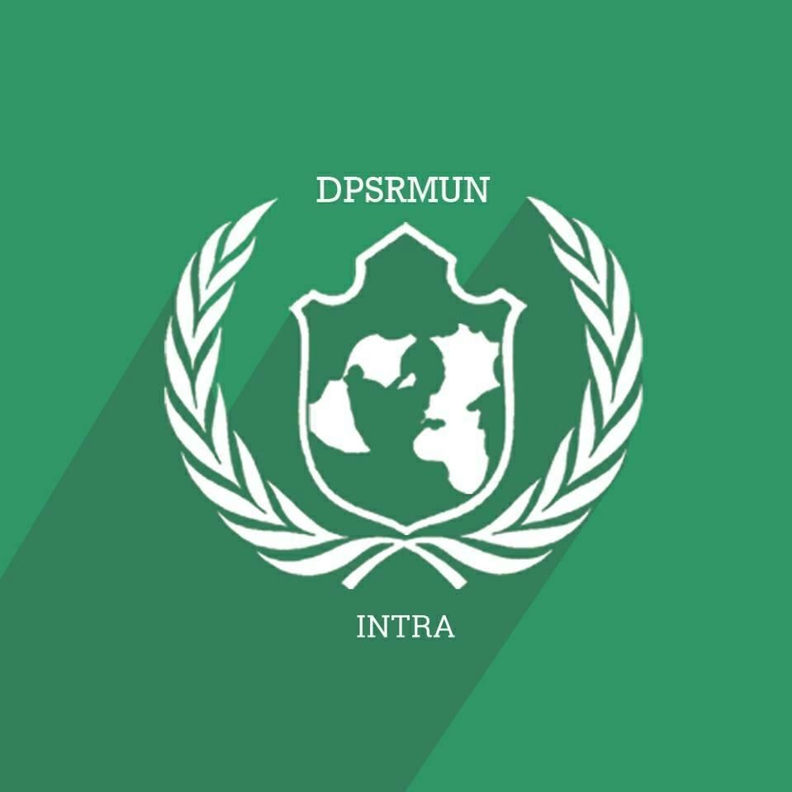**BACKGROUND GUIDE**

**AGENDA: Refugees, Internally Displaced Persons, and the Right to Humanitarian Aid with special emphasis on Middle East and south- east Asia**

## Executive Board:

## Chairperson: Alumni

## Vice Chairperson: Himja Behl and Saadhvi Bhan

## LETTER FROM EXECUTIVE BOARD:

Greetings Ambassadors, We welcome you to UNGA, at the 2017th edition of DPSR INTRA MUN 2017. We hope that the two days of the conference will be full of intense discussion and deliberation. We expect every ambassador to represent their country to the best of their abilities, and contribute fruitfully to debate. From each one of you, we expect impeccable diplomatic conduct- which includes diplomatic courtesy, effective lobbying and above all, compromising on negotiable grounds.

The committee will follow conventional ‗Model United Nations ‘Rules of Procedure, and will expect every ambassador to do the same. The following document gives a background on the agendas. The document should not be taken at its face value, and should only be used for giving direction to your research. Moreover, links have been provided to help you during the course of the same. As ambassadors, you will be expected to be thorough with your research and base your analysis and conclusions on the same during debate.

Please remember, a Council is only as strong as its individual ambassadors, and that the Executive Board is here merely to guide debate, not to take part in it. We expect the three days of DPSR INTRA MUN 2017 to be an immense learning experience. Please feel free to revert to the Executive Board, for any queries you may have.

### Study Guides, contrary to popular belief, are not supposed to contain all the information on a certain topic. A good study guide consists of content that an ambassador can use to gain basic information on the issue at hand and the links for further research that they may use to prepare for the final conference.

**PROOF/EVIDENCE IN COUNCIL:**

Evidence or proof is acceptable from the following sources:

### News Sources*:

1. **REUTERS** – Any Reuters article which clearly makes mention of the fact or is in contradiction of the fact being stated by an ambassador in council. (<http://www.reuters.com/>)
2. **State operated News Agencies** – These reports can be used in the support of or against the State that owns the News Agency. These reports, if credible or substantial enough, can be used in support of or against any Country as such but in that situation, they can be denied by any other country in the council. Some examples are,

I. Sputnik News (Russia) <https://sputniknews.com/>

1. IRNA (Iran) <http://www.irna.ir/ENIndex.htm>
2. BBC (United Kingdom) <http://www.bbc.co.uk/>

Iv. Xinhua News Agency and CCTV (P.R. China) <http://cctvnews.cntv.cn/>

1. **Government Reports:** These reports can be used in a similar way as the State Operated News Agencies reports and can, in all circumstances, be denied by another country. However, nuance is that a report that is being denied by a certain country can still be accepted by the Executive Board as credible information.

Examples are,

a.**Government Websites** like the State Department of the United States of America <http://www.state.gov/index.htm> or the Ministry of Defence of the Russian Federation<http://www.eng.mil.ru/en/index.htm>

1. **Ministry of Foreign Affairs** of various nations like India (<http://www.mea.gov.in/>), People‘s Republic of China (<http://www.fmprc.gov.cn/eng/>), France (<http://www.diplomatie.gouv.fr/en/>), Russian Federation (<http://www.mid.ru/brp_4.nsf/main_eng>)
2. Permanent Ambassadors to the United Nations Reports:

### [http://www.un.org/en/members/](http://www.un.org/en/members/%20) (Click on any country to get the website of the Office of its Permanent Ambassador.

1. **Multilateral Organizations** like the NATO (<http://www.nato.int/cps/en/natolive/index.htm>), ASEAN ([http://www.aseansec.org/),](http://www.aseansec.org/)) OPEC (<http://www.opec.org/opec_web/en/>), etc.
2. **UN Reports:** All UN Reports are considered are credible information or evidence for the

Executive Board of the Security Council.

* 1. **UN Bodies:** Like the SC ([http://www.un.org/Docs/sc/),](http://www.un.org/Docs/sc/)) GA (<http://www.un.org/en/ga/>), HRC (<http://www.ohchr.org/EN/HRBodies/HRC/Pages/HRCIndex.aspx>) etc.
  2. UN Affiliated bodies like the International Atomic Energy Agency (<http://www.iaea.org/)> World Bank (<http://www.worldbank.org/>) , International Monetary Fund (<http://www.imf.org/external/index.htm>) , International Committee of the

Red Cross (<http://www.icrc.org/eng/index.jsp>), etc.

C. Treaty Based Bodies like the Antarctic Treaty System (<http://www.ats.aq/e/ats.htm>, the International Criminal Court (<http://www.icc-cpi.int/Menus/ICC>)

*Under no circumstances will sources like Wikipedia (<http://www.wikipedia.org/>), Amnesty International (<http://www.amnesty.org/>), Human Rights Watch (<http://www.hrw.org/>) or newspapers like the Guardian (<http://www.guardian.co.uk/>),

Times of India [(h](http://timesofindia.indiatimes.com/))t[tp://timesofindia.indiatimes.com/),](http://timesofindia.indiatimes.com/)) etc. be accepted. SOME IMPORTANT LINKS

<http://www.reuters.com/>- Reuter’s news agency. <https://sputniknews.com/> - Russia official news agency. <http://www.irna.ir/ENIndex.htm> – Iran official news agency. <http://www.bbc.co.uk/>- UK national news agency.

<http://cctvnews.cntv.cn/> People‘s Republic of China national news agency. <http://www.state.gov/index.htm> US Department of State. <http://www.mea.gov.in/> Ministry of external Affairs India.

<http://www.fmprc.gov.cn/eng/>ministry of foreign affairs of the People‘s Republic of China.

<http://www.diplomatie.gouv.fr/en/>Foreign Ministry France.

<http://www.mid.ru/brp_4.nsf/main_eng>- The Ministry of Foreign Affairs Russian Federation.

<http://www.un.org/en/members/> (Click on any country to get the website of the Office of its Permanent Ambassador.)

<http://www.aseansec.org/>The Association of Southeast Asian Nations. [http://www.un.org/Docs/sc /](http://www.un.org/Docs/sc/) United Nation Security Council. <http://www.un.org/en/ga/> -United Nation General Assembly.

[http://www.icrc.org/en g/index’s](http://www.icrc.org/en%20g/index.jsp) - The International Committee of the Red Cross.

<http://www.icc-cpi.int/Menus/ICC>- International Criminal Court...

<http://www.un.org/en/peacekeeping/about/dpko/> -Department of Peacekeeping Operations

## ABOUT THE UNITED NATIONS GENERAL ASSEMBLY:

Established in 1945 under the Charter of the United Nations, the General Assembly occupies a central position as the chief deliberative, policymaking and representative organ of the United Nations. Comprising all 193 Members of the United Nations, it provides a unique forum for multilateral discussion of the full spectrum of international issues covered by the Charter. It also plays a significant role in the process of standard-setting and the codification of international law. The Assembly meets in regular session intensively from September to December each year, and thereafter as required.

According to the Charter of the United Nations, the General Assembly may:

1. Consider and make recommendations on the general principles of cooperation for maintaining international peace and security, including disarmament;
2. Discuss any question relating to international peace and security and, except where a dispute or situation is currently being discussed by the Security Council, make recommendations on it;
3. Discuss, with the same exception, and make recommendations on any questions within the scope of the Charter or affecting the powers and functions of any organ of the United Nations;
4. Initiate studies and make recommendations to promote international political cooperation, the development and codification of international law, the realization of human rights and fundamental freedoms, and international collaboration in the economic, social, humanitarian, cultural, educational and health fields;
5. Make recommendations for the peaceful settlement of any situation that might impair friendly relations among nations;
6. Receive and consider reports from the Security Council and other United Nations organs;
7. Consider and approve the United Nations budget and establish the financial assessments of Member States;
8. Elect the non-permanent members of the Security Council and the members of other United Nations councils and organs and, on the recommendation of the Security Council, appoint the Secretary-General.

While the Assembly is empowered to make only non-binding. Recommendations to States on international issues within its competence, it has, nonetheless, initiated actions—political, economic, humanitarian, social and legal—which have affected the lives of millions of people throughout the world.

# WHO IS A REFUGEE?

A refugee is someone who has been forced to flee his or her country because of persecution, war, or violence. A refugee has a well-founded fear of persecution for reasons of race, religion, nationality, political opinion or membership in a particular social group. Most likely, they cannot return home or are afraid to do so. War and ethnic, tribal and religious violence are leading causes of refugees fleeing their countries.

# WHO IS AN INTERNALLY DISPLACED PERSON?

People forced to flee their homes but never cross an international border. These individuals are known as Internally Displaced Persons, or IDPs. These individuals seek safety anywhere they can find it—in nearby towns, schools, settlements, internal camps, even forests and fields. IDPs, which include people displaced by internal strife and natural disasters, are the largest group that UNHCR assists. Unlike refugees, IDPs are not protected by international law or eligible to receive many types of aid because they are legally under the protection of their own government.

Countries with some the largest internally displaced populations are Colombia, Iraq and South Sudan.

# WHO IS A STATELESS PERSON?

A stateless person is someone who is not a citizen of any country. Citizenship is the legal bond between a government and an individual, and allows for certain political, economic, social and other rights of the individual, as well as the responsibilities of both government and citizen. A person can become stateless due to a variety of reasons, including sovereign, legal, technical or administrative decisions or oversights. The Universal Declaration of Human

Rights underlines that “Everyone has the right to a nationality.”

# WHO IS AN ASYLUM SEEKER?

When people flee their own country and seek sanctuary in another country, they apply for asylum – the right to be recognized as a refugee and receive legal protection and material assistance. An asylum seeker must demonstrate that his or her fear of persecution in his or her home country is well-founded.

# WHAT IS THE 1951 REFUGEE CONVENTION?

The 1951 Geneva Convention is the main international instrument of refugee law. The Convention clearly spells out who a refugee is and the kind of legal protection, other assistance and social rights he or she should receive from the countries who have signed the document. The Convention also defines a

refugee’s obligations to host governments and certain categories or people, such as war criminals, who do not qualify for refugee status. The Convention was limited to protecting mainly European refugees in the aftermath of World War II, but another document, the 1967 Protocol, expanded the scope of the Convention as the problem of displacement spread around the world.

# MILLIONS OF SYRIANS DISPLACED:

The conflict in Syria, now in its seventh year, was the world’s biggest producer of refugees (5.5 million). Humanitarian needs in Syria have increased significantly since the beginning of the crisis, with 13.5 million people in need of humanitarian assistance, including more than 6 million children. Over 400,000 people have been killed and more than 1 million injured since 2010.

Many Syrians have been forced to leave their homes, often multiple times, making Syria the largest displacement crisis in the world with 6.3 million people internally displaced and almost 4 million people registered as refugees in neighboring countries. An estimated 4.53 million people are in need of humanitarian assistance in hard-to-reach areas and besieged locations.

Turkey hosts over 2.9 million registered Syrians. The majority of them live in urban areas, with around 260,000 accommodated in the 21 government-run refugee camps. There are more than a million registered Syrians in Lebanon and 660,000 in Jordan. Iraq has also seen a growing number of Syrians arriving, hosting more than 241,000, while in Egypt UNHCR provides protection and assistance to more than 122,000.

Palestine refugees are particularly vulnerable with an estimated 460,000 people receiving regular assistance around Syria. School attendance has dropped by more than 50 per cent and roughly one-quarter of schools have been damaged, destroyed or are used as collective shelters. More than half of Syria's hospitals have been destroyed or badly damaged. Water supply has decreased to less than 50 per cent of its pre-crisis levels. An estimated 9.8 million people are considered food insecure and many more are living in poverty.

# MYANMAR’S ROHINGYA REFUGEE CRISIS:

Religious clashes in Myanmar, a Buddhist-majority country, have driven more than 400,000 Rohingya Muslims out of the country, provoking the United Nations’ top human rights official to call the campaign against them “ethnic

cleansing.” It’s tarnished the reputation of the country’s de facto leader, Aung San Suu Kyi: Her long silence on the violence has had some critics petitioning to rescind her 1991 Nobel Peace Prize. It has raised doubts about whether Myanmar can keep attracting the levels of foreign investment the Southeast Asian nation has counted on to modernize the economy since it opened up to the outside world six years ago.

#### 1. What’s causing the violence?

The latest tensions were [sparked](https://www.crisisgroup.org/asia/south-east-asia/myanmar/myanmar-tips-new-crisis-after-rakhine-state-attacks) on Aug. 25 when militants from the Arakan Rohingya Salvation Army attacked 25 police and army posts, killing a dozen security officials in the eastern state of Rakhine. The military responded with

what it calls “clearance operations.” There have been [reports](https://www.hrw.org/news/2017/09/15/burma-military-torches-homes-near-border) of security forces and Buddhist vigilantes indiscriminately attacking Muslims in the state and burning their villages. The army said more than 400 people have died, most of them militants, while human-rights groups say hundreds of villagers have been killed. The military’s response has been similar to its reaction after an ARSA operation in October 2016: UN investigators concluded soldiers “[very likely](http://www.euronews.com/2017/02/03/rohingya-very-likely-victims-of-crimes-against-humanity)” committed crimes against humanity. An estimated 87,000 Rohingya fled Myanmar then.

#### Who are the Rohingya?

Many, though not all, of the Muslims living in the northern part of Rakhine identify as Rohingya. The Rohingya stress [the fact](http://www.rakhinecommission.org/app/uploads/2017/08/FinalReport_Eng.pdf) that a Muslim community existed in the state, the site of independent kingdoms since antiquity, before Burma took control of Rakhine in 1784. Their critics call the Muslims foreign interlopers and emphasize that during British colonial rule, starting in the 1820s, workers from Bengal, in what is now Bangladesh, arrived in Rakhine and the Muslim community grew significantly. Myanmar’s government refuses to use the word Rohingya, as that might imply the Muslims of Rakhine are a distinct ethnic group, deserving of recognition. A minority of Rohingya

are [Hindus](https://thewire.in/173972/hindus-myanmar-muslim-rohingyas-refuge-bangladesh/).

#### How have the Rohingya been treated?

Myanmar’s authorities have progressively denied the Rohingya rights and, along with vigilantes sometimes led by Buddhist monks, persecuted them, driving them from their homes and into neighboring countries, mostly Bangladesh. In 1982, the government stripped the Rohingya of citizenship. In the name of bringing order to Rakhine, the army launched an operation in 1991 featuring forced labor, rape and religious suppression. The Rohingya face numerous [legal restrictions](https://www.cfr.org/backgrounder/rohingya-migrant-crisis). Couples need government permission to marry and to travel beyond their home town or move to a new one. Those in two of Rakhine’s cities are limited to having two children.

#### What has Suu Kyi done?

Mindful of the near-universal dislike of the Rohingya among Myanmar’s other communities, Suu Kyi has blasted international criticism of the current crisis as fake news. “A huge iceberg of misinformation” is creating divisions in society to promote the interests of terrorists, she said early this month. Suu Kyi toned down her message in a televised address on Sept. 19, saying her government was ready to welcome back Rohingya refugees. She condemned human rights violations and unlawful violence but stopped short of directly criticizing the military. In September 2016, she requested that the Kofi Annan Foundation along with her office form an advisory commission to examine the situation in Rakhine. Its final report in August recommended speeding up the citizenship verification process for the country’s stateless community and regulating the rights of non-citizens who live in Myanmar. The commission also recommended a review of the 1982 citizenship law.

#### How threatening are Rohingya militants?

While Myanmar’s Rohingya don’t have a history of radicalization, the attacks on border guard police bases in Rakhine in October 2016 marked

the [emergence](https://www.crisisgroup.org/asia/south-east-asia/myanmar/283-myanmar-new-muslim-insurgency-rakhine-state) of a new insurgency. Support for the ARSA militants is difficult to gauge, but the vast majority of Rohingya are believed to be opposed to violence.

#### What does the crisis mean for foreign investment?

The crisis threatens to sap investor confidence in the nation, which saw the

U.S. and European countries drop sanctions after a ruling military junta released Suu Kyi from house arrest in 2010. Companies that rushed in are again worried about risks from human rights concerns. Foreign investment plunged 30 percent last fiscal year after a record $9.5 billion was pumped into the economy the prior 12 months. The shortfall coincided with concern over the direction of the government’s economic agenda and an increased focus on Rakhine.

# SOUTH SUDAN REFUGEE CRISIS:

#### WHERE IS SOUTH SUDAN?

South Sudan is the world's newest nation, in the centre of Africa bordered by six countries. It is rich in oil, but following decades of civil war it is also one of the least developed regions on earth - only 15% of its citizens own a mobile phone and there very few tarmac roads in an area bigger than Spain and Portugal combined.

#### WHAT’S HAPPENING IN SOUTH SUDAN?

On 15 December 2013, conflict broke out in the South Sudanese capital, Juba, among members of the South Sudanese People’s Liberation Movement (SPLM). The fighting, between those who supported President Salva Kiir, a member of the Dinka tribe, and recently ousted Vice President Riek Machar, a Nuer, has sparked a major humanitarian crisis. The violence has rapidly escalated since it began and has spread to other parts of the country, leaving more than 1.35 million people displaced and a staggering 4.9 million people in need of humanitarian assistance (OCHA). To give some context, if we combine the populations in WA, SA, NT and Tasmania, this still doesn’t make up the entire numbers in need in South Sudan. The scale is simply extraordinary.

#### HUMANITARIAN SITUATION AND NEEDS:

As the youngest and one of the least developed countries in the world, South Sudan suffers from decades of conflict and neglect, corruption and mismanagement. Despite a 2015 peace agreement, the conflict which was initially confined to 3 states has gradually expanded across the country.

Extreme violence coupled with an economic crisis and worsening food insecurity has led to a crisis of unprecedented proportions.

Extreme levels of food insecurity are expected across South Sudan through the first half of 2017. The Integrated Food Security Phase Classification (IPC) estimates that 5.5 million people will be severely food insecure. 100 000 people are about to succumb to famine in two counties of Unity state, according to the UN. In the Greater Equatoria region, traditionally considered the country’s bread basket, violence has disrupted food supply routes and an estimated 50% of all harvests have been lost in the conflict-affected areas.

This man-made humanitarian disaster has left at least 1.89 million people internally displaced, mostly due to widespread violence against civilians. Almost 224 000 people have taken refuge in overcrowded protection-of- civilian (PoC) sites at 6 UN bases, and a staggering 1.5 million South Sudanese have taken refuge in Ethiopia, Kenya, Sudan and Uganda. More than 725 000 South Sudanese are now being hosted in Uganda where authorities are trying to keep up with the mass influx by identifying new settlements for the refugees. Every day, on average 4700 refugees continue to cross into Uganda. The South Sudanese crisis could have a destabilising effect on the wider region, parts of which are experiencing severe drought and food shortages after consecutive failed rainy seasons.

The health care sector is in dire straits. Since December 2013, 106 health facilities have been closed, while many others have been looted or destroyed. With more than 2 million cases and 558 deaths, malaria was the leading cause of death and illness in 2016. South Sudan also continues to experience its longest cholera outbreak in recent years, with 3962 cases including 75 deaths since June 2016. There were also numerous measles outbreak. The disease is particularly life-threatening for children under the age of five, especially when malnourished. The capacity of the health system to deliver effective services pales in comparison to the magnitude of needs. It depends nearly entirely on humanitarian assistance, which is subject to funding and access constraints.

Humanitarian aid is delivered in extremely challenging circumstances, when and where possible. Violence, harassment and intimidation against humanitarian workers have already resulted in the death of 67 aid workers since December 2013 and continue to hamper the work of organisations.

Moreover,

humanitarian workers are faced with seizure of their assets, illegal obstructions and efforts to tax and divert relief aid. The recent fighting has provided a cover for the widespread and systematic looting by all armed forces.